The tutorials for the projects of Linux programing
阮越
March 37，2019

Contents

Project 1 Basic Commands of Linux 3
1 Goal 3
2 Steps 3
3 Summary 5
Project 2 Shell programming 6
1 Goal 6
2 Steps 6
3 Summary 8
4 Codes List 8
Project 3 File operation with Linux C programming 10
1 Goal 10
2 Steps 10
3 Summary 11
4 Codes List 11
Project 4 Linux process operation and inter-process communication 15
1 Goal 15
2 Steps 15
3 Summary 16
4 Codes List 16
Project 5 Linux thread 19
1 Goal 19
2 Steps 19
3 Summary 20
4 Codes List 20
Project 6 IPC 23
1 Goal 23
2 Steps 23
3 Summary 24
4 Codes List 24
Project 7 Socket 30
1 Goal 30
2 Steps 30
3 Summary 30
4 Codes List 30

Project 1 Basic Commands of Linux

1 Goal
Be familiar with basic Linux commands.

2 Steps
Step1: Use the command pwd to check the current working directory, then use the ls command with different parameters -a,-l, -f, -a, -lf to view the files in the current directory. Record the results of these comments.
___________________________________________________________________________________________________________________________________________________________________________________________________________________________________________________________________________________________________________________________________________________________________________________________________________
Step 2: Create a new directory “test” in the current directory, then change the working directory to “test”, and copy the file /etc/passwd into this directory (cp). Then check the owner and permissions of the new file “passwd” in the current directory.
_____________________________________________________________________________________________________________________________________________________________________________________________________________________________________________
Step 3: Try to write something to the new passwd file in the current directory and the file /etc/passwd (using the command echo "string" >> file). If it does not work, describe the reason. Use command cat, more and less to display the contents of the file password. Compare the display effect among these commands.
_____________________________________________________________________________________________________________________________________________________________________________________________________________________________________________
Step 4：Use command ls to check the permission of the file passwd in the current directory, use command mv to rename the file name of password as test.txt, try to change the file owner as root and group as root with chown and chgrp, and change the permission as "-rw------" with command chmod. If these commands don't work, explain why. _____________________________________________________________________________________________________________________________________________________________________________________________________________________________________________
Step 5: Use command rm to delete all the files in the directory test，and then use command rmdir to delete directory test. (Is there a command which can delete the directory and all files in the directory. If so, write this command）
_______________________________________________________________________________
Step 6：Use command ps to view the processes in the current system, and use command man to get the parameters of ps, write the command about how to get the process information on terminal with ps.
_______________________________________________________________________________
Step 7：Use the command df to view the space usage of each individual file system on the current system.
_____________________________________________________________________________________________________________________________________________________________________________________________________________________________________________
Step 8：Use the command du to see how much space the user's working directory takes up and record the results.
_____________________________________________________________________________________________________________________________________________________________________________________________________________________________________________
Step 9：Use the command free to see how memory resources are being used.
_____________________________________________________________________________________________________________________________________________________________________________________________________________________________________________
Step 10：Use man to get the help information of commands tar and gzip, package and compress the files in the test directory with tar and gzip, then unpack it under another directory TMP.
_____________________________________________________________________________________________________________________________________________________________________________________________________________________________________________
Step 11：Run command "ls -l > tmp", see what happens when this command is executed. Explain this command.
_____________________________________________________________________________________________________________________________________________________________________________________________________________________________________________
Step 12：Try to execute “find /usr/src -name *.c -print | xargs grep “#include”, see what happens when this command is executed, and explain it.
_____________________________________________________________________________________________________________________________________________________________________________________________________________________________________________
Step 13：Execute the commands cal and date. Tell what they did.
_____________________________________________________________________________________________________________________________________________________________________________________________________________________________________________
Step 14：Execute the commands clear and logout to exit the system. (think of any other ways to do this.)
______________________________________________________________________________________________________________________________________________________________
Step 15：Execute the command shutdown to shutdown the sysytem. (Is there an easier way to do this?)
_______________________________________________________________________________

3 Summary
_________________________________________________________________________________________________________________________________________________________________________________________________________________________________________________________________________________________________________________________________________________________________________________________________________________________________________________________________________________________________________________________________________________________________________

Project 2 Shell programming
- Goal
- Learn the basic way to use vi.
- Learn how to do shell programming.

2 Steps
2.1 vi
Step 1：Login the Linux as user stu.
Step 2：Start vi and switch to insert mode, enter the following words:
This is an exercise!
We use vi to do the edit.
Left, down, up, right.
Step 3：Search pattern in this file. Write the command and the result.
命令模式下键入”/is”，回车
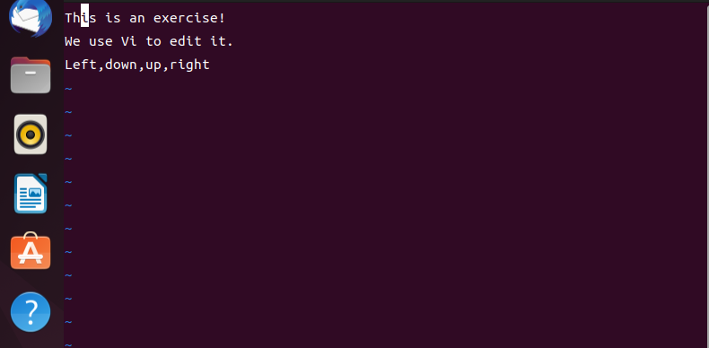
Step 4：Substitute one string. Write the command and the result.
命令模式下键入”2s”，然后键入要替换的字符
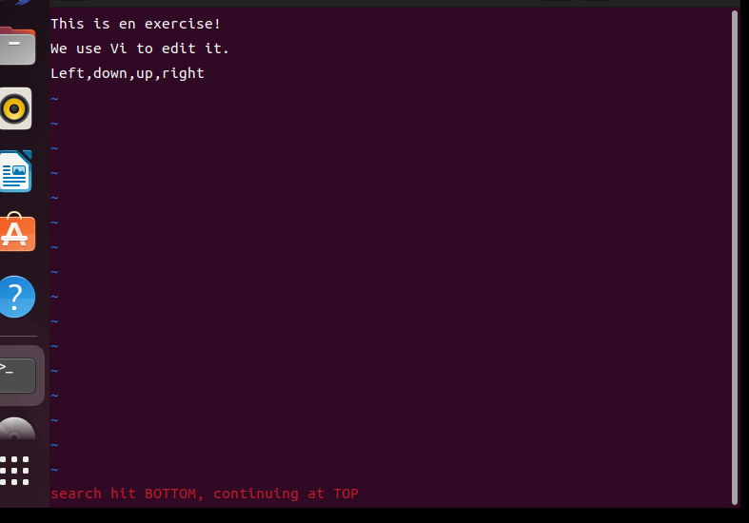
Step 5：Copy/cut and paste some lines in the file. Write the command and the result.
命令模式下键入”yy”，光标所在行被复制，将光标移动到某一行，键入”p”
命令模式下键入”2dd”，光标所在行之后的连续两行将被删除
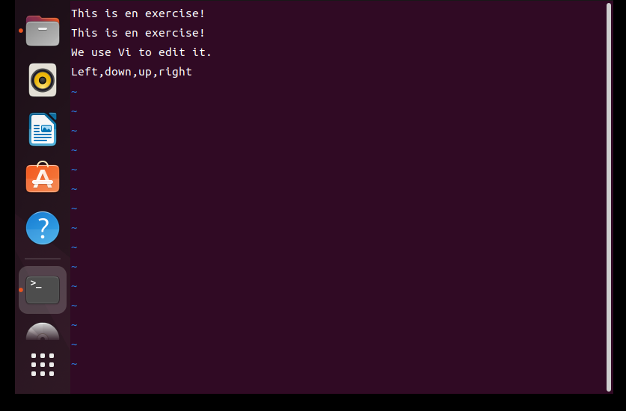
Step 6：Copy/cut and paste some words in the file. Write the command and the result.
命令模式下键入”2yw”，光标所在位置的连续两个单词将被复制
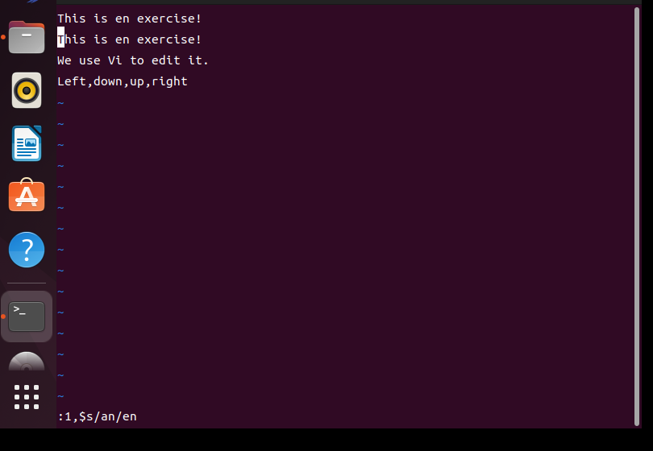
Step 7：How to repeat the last command or undo the last command.
命令模式下键入”4yy”，然后移动光标到要复制的位置，原光标所在行连续4行的内容被复制
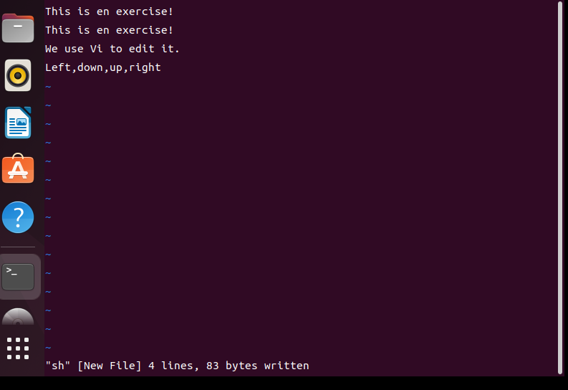
Step 8：Write the command of how to quit or write and quit.
命令模式下键入”:wq”
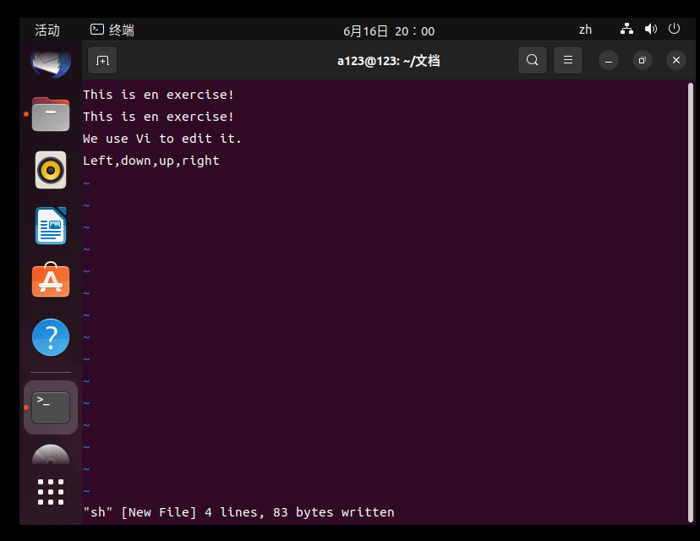
2.2 Shell programming
Step 1：Use vi to input Codes List 2-1.
Step 2：Run the program. If it cannot be executed, try to analyze the reason and fix it.
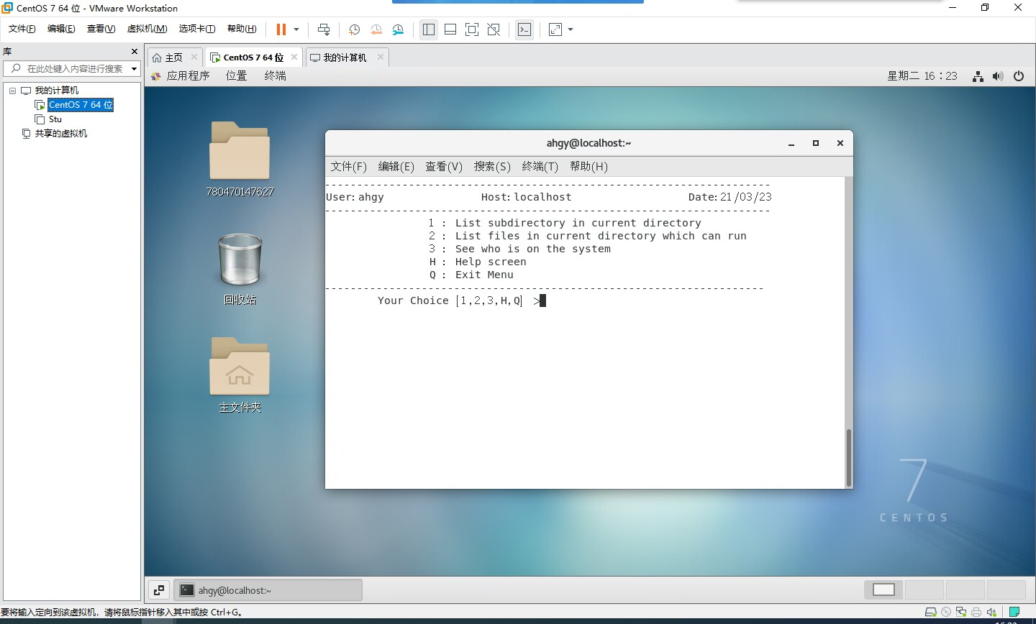
Step 3：Record the result of this program.
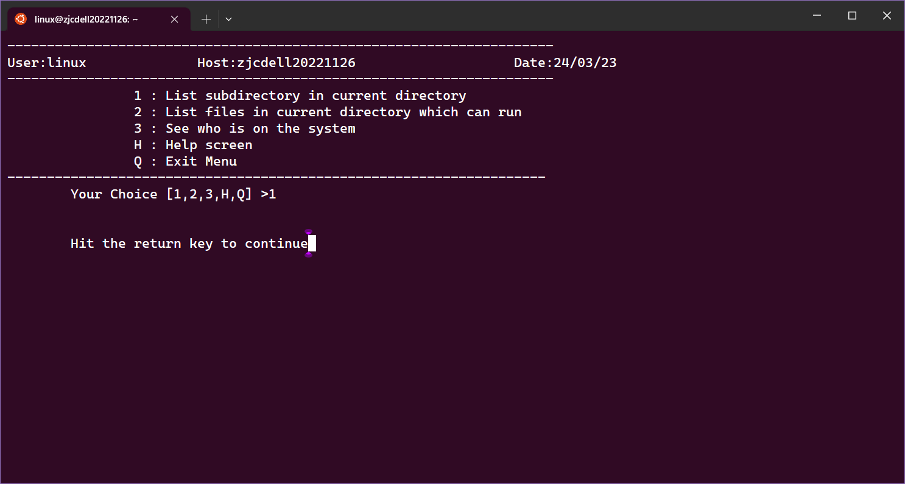
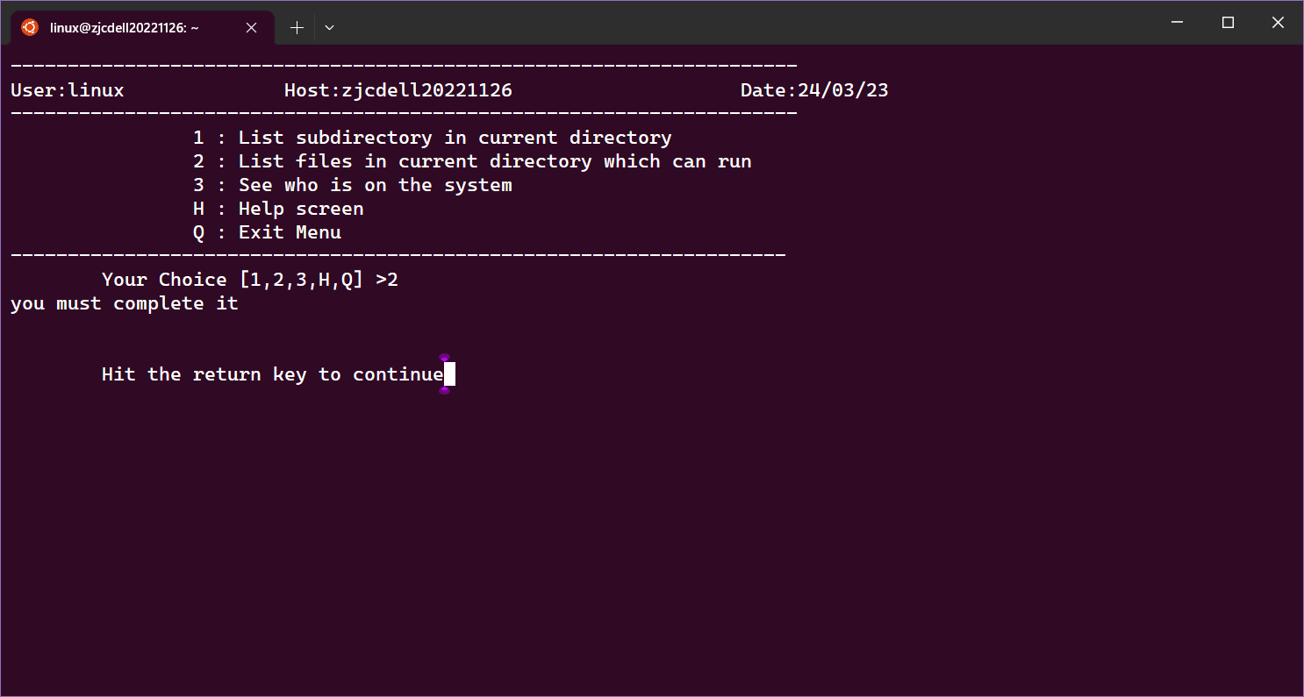
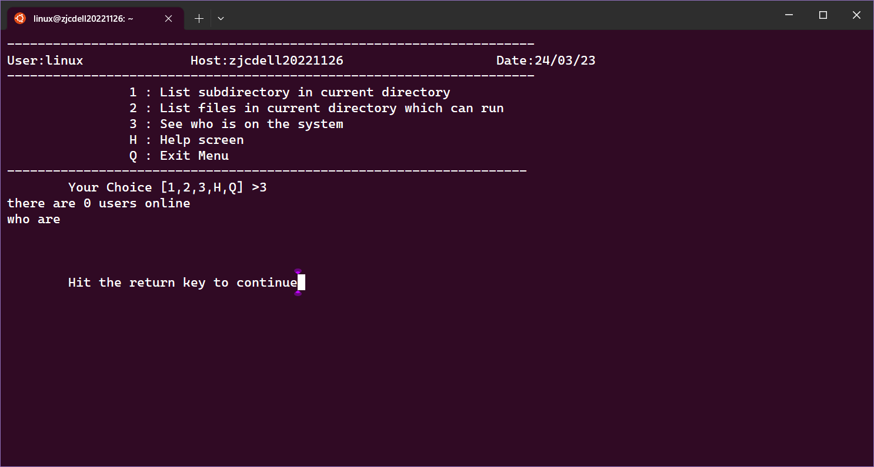
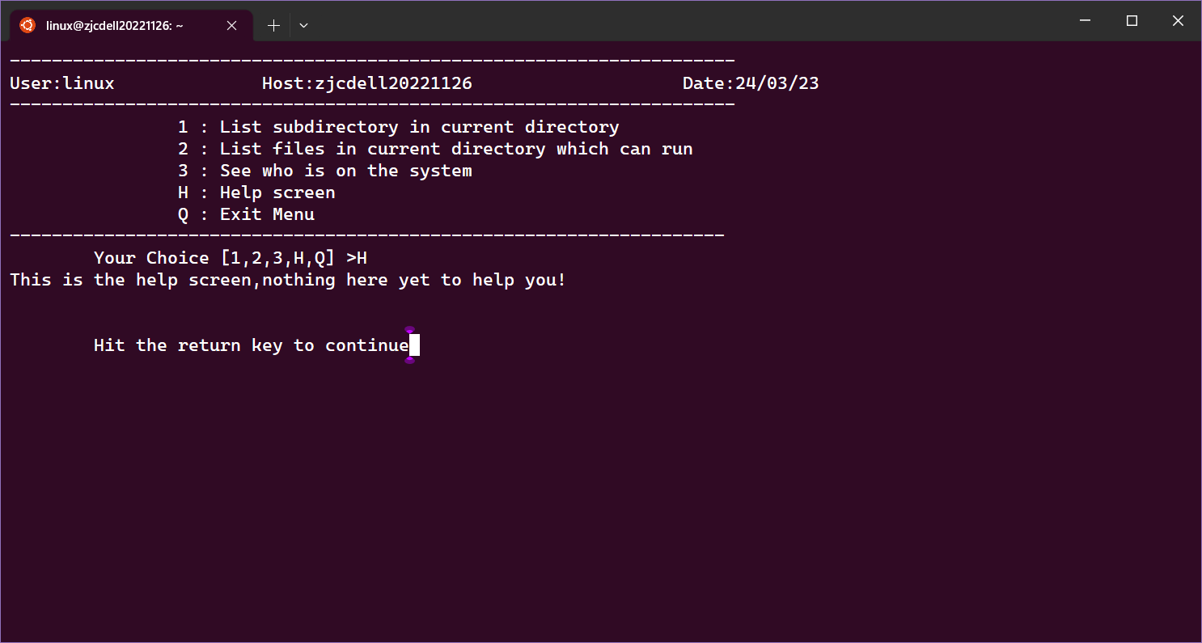
Step 4：Read the code, complete the function file_run().
file_run()
{
# 列出当前目录下的所有可执行文件
echo "Executable files in current directory:"
find . -maxdepth 1 -type f -executable -printf "%f\n"
}
Step 5：Modify function uers(), so as to display online users without breaking lines.
uers()
{
echo "there are `who|wc -l` users online"
for i in "who are\n`who|awk '{print $1}'`"
do
echo -n $I
echo -n " "
done
}

3 Summary
这个脚本定义了一个菜单，包含了四个选项：列出当前目录下的所有子目录、列出当前目录下的所有可执行文件、显示当前在线的用户、显示帮助信息和退出菜单。在脚本中，我们使用了 ls -l 命令和 awk 命令来列出当前目录下的所有子目录和可执行文件，使用 who 命令来显示当前在线的用户。脚本会不断循环显示菜单，直到用户选择退出菜单。

4 Codes List
#2-1 menu
MYDATE=`date +%d/%m/%y`
THIS_HOST=`hostname -s`
USER=`whoami`

file_run()
{
echo "you must complete it"
}
uers()
{
echo "there are `who|wc -l` users online"
echo -e "who are\n`who|awk '{print $1}'`"
}

while :
do
tput clear
cat <<aaa
---------------------------------------------------------------------
User:$USER Host:$THIS_HOST Date:$MYDATE
---------------------------------------------------------------------
1 : List subdirectory in current directory
2 : List files in current directory which can run
3 : See who is on the system
H : Help screen
Q : Exit Menu
--------------------------------------------------------------------
aaa
echo -e -n "\tYour Choice [1,2,3,H,Q] >"
read CHOICE
case $CHOICE in
1) ls -l|awk '/^d/ {print $8}'
;;
2) file_run
;;
3) uers
;;
H|h)
cat <<aaa
This is the help screen,nothing here yet to help you!
aaa
;;
Q|q) exit 0
;;
*) echo -e "\t\007 unkown user response"
;;
esac
echo -e -n "\n\n\tHit the return key to continue"
read DUMMY
done

Project 3 File operation with Linux C programming
- Goal
- Learn how to use gcc.
- Learn system calls and C function related to file operation.
- Try to implement the code of step 6.

2 Steps
Step 1：Use vi to input code 3-1 and code 3-2, and create file “file.in” and “file.out”.
Step 2：Compile these two programs by gcc, write the compile command and result of the program.
Step 3：Read these Codes List, compare the usage of standard C file operations with Linux system calls open, read, write, and so on.
Step 4：Follow the comments to modify program 3-2 and use the time command to see the time efficiency of each program.
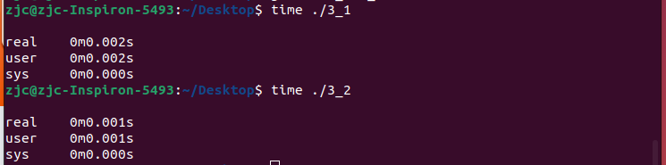
Step 5：Input, compile and run the program 3-3 and 3-4, record the results and compare fseek and lseek.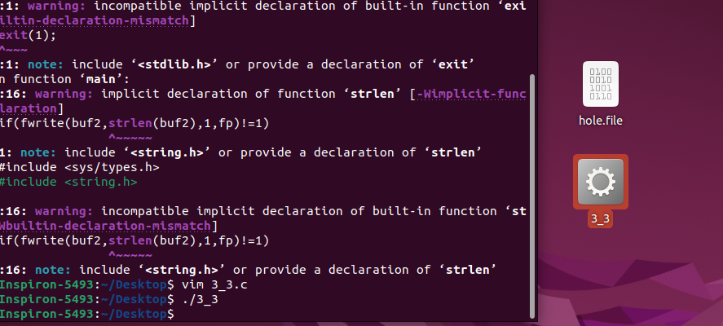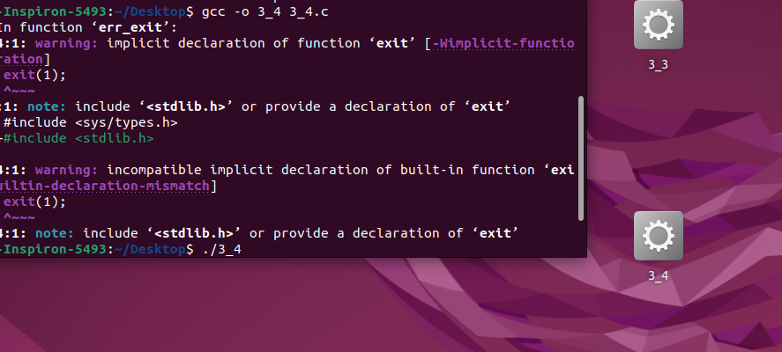

Step 6：Use standard C function and Linux system call respectively to create a C program to operate (insert, modify and delete) the basic information of students which are stored in a file. The basic information of students is defined as the following structure stu_info:
struct stu_info {
char stu_num[12];
char name[10];
short int sex;/*0 is labeled as female, 1 is labeled as male*/
char mobile_phone[12];
};

3 Summary

4 Codes List
// 3-1
#include <stdio.h>
#include <stdlib.h>
int main(void)
{
char c;
FILE *in,*out;

if((in = fopen("file.in","r"))==NULL)
{
perror("file open error!");
exit(0);
}

out = fopen("file.out","w");

while((c = fgetc(in))!=EOF)
fputc(c,out);

}

// 3-2
#include <unistd.h>
#include <sys/stat.h>
#include <fcntl.h>

int main()
{
// char block[1024];
char c;
int in, out;
int nread;

in = open("file.in", O_RDONLY);
out = open("file.out", O_WRONLY|O_CREAT, S_IRUSR|S_IWUSR);
// Open this comment, and comment the last while statements, then recompile and execute.
// while((nread = read(in,block,sizeof(block))) > 0)
while((nread = read(in,&c,sizeof(c))) > 0)
// write(out,block,nread);
write(out,&c,nread);

}

// 3-3
#include <stdio.h>
#include <unistd.h>
#include <fcntl.h>
#include <sys/stat.h>
#include <sys/types.h>

char buf1[] = "abcdefghij";
char buf2[] = "ABCDEFGHIJ";

void err_exit(char *err_s)
{
perror(err_s);
exit(1);
}

int main(void)
{
FILE *fp;

if((fp = fopen("hole.file","w")) == NULL)
err_exit("file open fail!");

if(fwrite(buf1,sizeof(buf1),1,fp)!=1)
err_exit("file write buf1 error!");

if(fseek(fp,40,SEEK_SET)==-1)
err_exit("fseek error!");

if(fwrite(buf2,strlen(buf2),1,fp)!=1)
err_exit("file write buf2 error!");

fclose(fp);
}

// 3-4
#include <stdio.h>
#include <unistd.h>
#include <fcntl.h>
#include <sys/stat.h>
#include <sys/types.h>

char buf1[] = "abcdefghij";
char buf2[] = "ABCDEFGHIJ";

void err_exit(char *err_s)
{
perror(err_s);
exit(1);
}

int main(void)
{
int fd;

if((fd = open("hole.file",O_WRONLY|O_CREAT/*|O_APPEND,0644*/)) == -1)
err_exit("file open fail!");

if(write(fd,buf1,10)!=10)
err_exit("file write buf1 error!");

if(lseek(fd,40,SEEK_SET)==-1)
err_exit("lseek error!");

if(write(fd,buf2,10)!=10)
err_exit("file write buf2 error!");
}

Project 4 Linux process operation and inter-process communication
- Goal
- Learn how to use system calls, fork etc. to manipulate process.
- Learn how to use pipe to implement the parent-child process communication.

2 Steps
Step1：Input, compile and run the code 4-1, learn the usage of system calls fork etc. 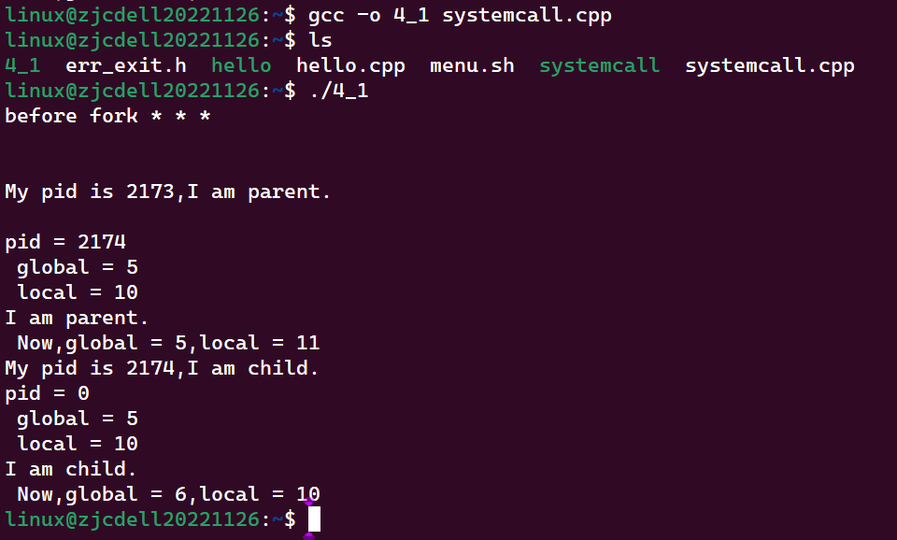
Step 2：Input code 4-2, 4-3 and 4-4 by vi, compile by gcc. Write the compile commands.
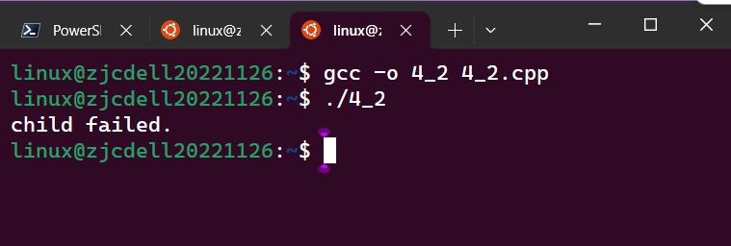
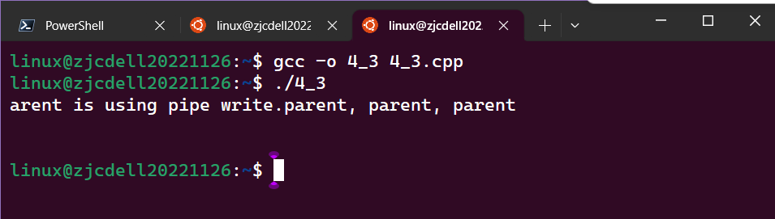
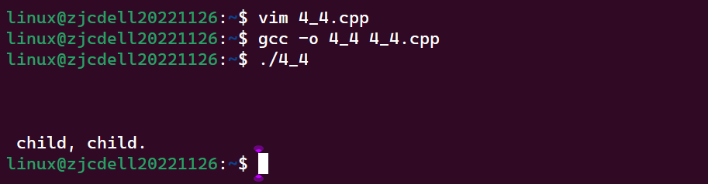
Step 3： Give Makefile that compile all these programs. Talk about the benefits of such doing.
__________________________________________________________________________________________________________________________________________________________________________________________________________________________________________________________________________________________________________________________________________________________________________________________________________________________________________________________________________________________
Step 4：Run these programs, write the results.
____________________________________________________________________________________________________________________________________________________________________________________________________________________________________________________________________________________________________________________________
Step 5：The execution result displayed on the screen belongs to which process? Why?
______________________________________________________________________________________________________________________________________________________________
Step 6：Does printf in the parent process output to the screen? Why?
______________________________________________________________________________________________________________________________________________________________
Step 7：Rewrite the program in step 6 of project 3 by means of pipe communication between parent and child processes. Require two processes, one is the parent which takes the user's command and pipes it to the child, the other is child which does the actual manipulation of the file stu.info.

3 Summary
_________________________________________________________________________________________________________________________________________________________________________________________________________________________________________________________________________________________________________________________________________________________________________________________________________________________________________________________________________________________________________________________________________________________________________

4 Codes List
// 4-1
#include <unistd.h>
#include <stdio.h>
#include "err_exit.h"
int global = 5;

int main(void)
{
pid_t pid;
char *string = "these are values before fork:";
int local = 10;
printf("before fork * * *\n\n");
if((pid = fork())<0)
err_exit("fork error");
if(pid == 0){
string = "I am child.";
printf("\nMy pid is %d,%s\n"
"pid = %d\n global = %d\n local = %d\n",
getpid(),string,pid,global,local);
global++;
}
else{
string = "I am parent.";
printf("\nMy pid is %d,%s\n"
"pid = %d\n global = %d\n local = %d\n",
getpid(),string,pid,global,local);
local++;
}
printf("%s\n Now,global = %d,local = %d\n",string,global,local);
exit(EXIT_SUCCESS);
}

// 4-2
# define STD_INPUT 0 // define standard input
# define STD_OUTPUT 1 // define standard output

int fd[2];
main()
{
static char process1[]=”father”,process2[]=”child”;

pipe(fd); // create pipe
pipeline(process1,process2);
exit(1);
}

pipeline(char* process1,char* process2)
{
int i;

if ((i=fork())==-1)
{
perror(“process fork error!”);
exit(1)；
}
if (i)
{
close(fd[0]); // close input fd of pipe
close(STD_OUTPUT); // close standard output 1
dup(fd[1]); // redefine 1 as output fd of pipe
close(fd[1]); // close the original output fd of pipe
execl(process1, process1, 0); // use father process to substitute current image
printf(“ father failed.\n”); // run execl() error
}
else
{
close(fd[1]); // close output fd of pipe
close(STD_INPUT); // close standard input 0
dup(fd[0]); // redefine 0 as input fd of pipe
close(fd[0]); // close the original input fd of pipe
execl(process2,process2,0); // use child process to substitute current image
printf(“child failed.\n”); // run execl() error
}
exit(2);
}

4-3 father.c
main()
{
static char string[] = “Parent is using pipe write.” ;
int len;

len = sizeof(string) ;
write(l, string, len) ; // write string into the pipe
printf(“parent, parent, parent \n \n \n” ) ;
exit(0) ;
}

4-4 child.c
main()
{
char output[30] ;
read (0, output, 30) ; // read data from pipe and write it to output
printf(“%s \n child, child. \n” , output) ;
return(0) ;
}

Project 5 Linux thread

1 Goal
Learn how to create and synchronize Linux threads.

2 Steps
Step 1：Input code 5-1, compile and run.
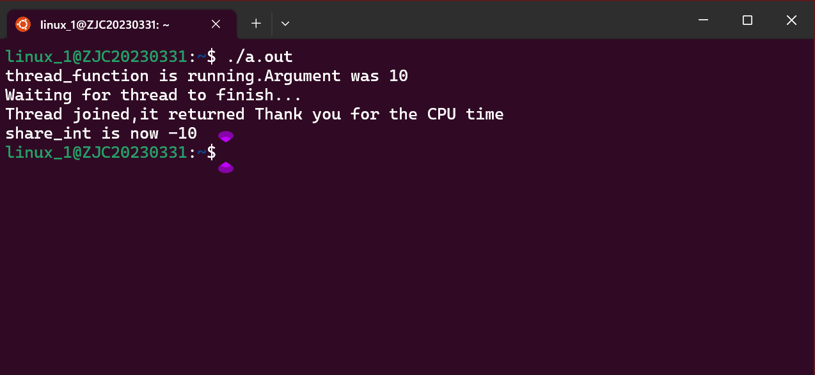
Step 2：Read the code thoroughly, describe the meaning of each parameter in the pthread_create() function, present the call method of the entry function of the thread, and describe the way parameters passing between two threads.
int pthread_create(pthread_t *thread, const pthread_attr_t *attr,void *(*start_routine)(void *),void*arg);
第一个参数为指向线程标识符的指针。
第二个参数用来设置线程属性。
第三个参数是线程运行函数的起始地址。
最后一个参数是运行函数的参数。
主线程通过pthread_create 函数向从线程a_thread传递share_int而从线程a_thread通过pthread_join向主线程传递thread_result
Step 3：Open the comment which is related to global variable aa. Answer the difference between this approach and the method manipulates it with process.
线程共用相同的数据区而各个进程有着自己独立的数据区。
Step 4：Input code 5-2, compile and run, record the result.
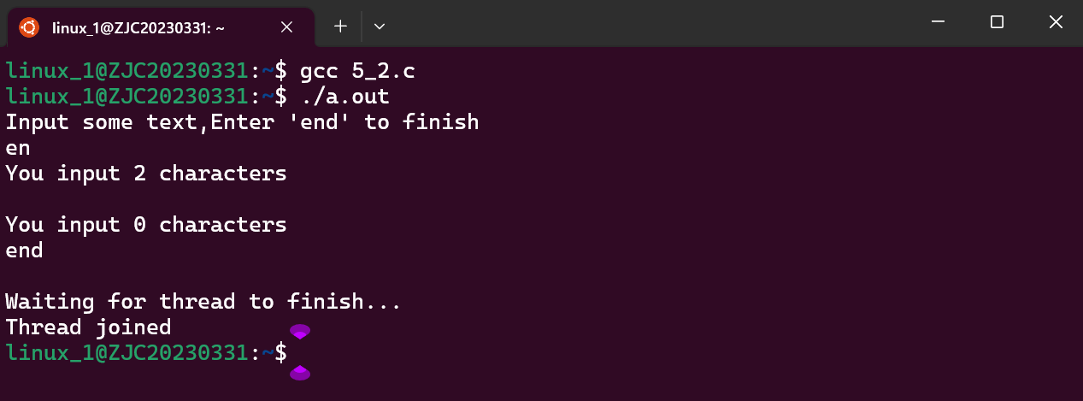
Step 5：Read the code thoroughly, describe how to use semaphores to synchronize threads.
sem_post以原子操作的方式将信号量加1从而唤醒线程。sem_wait以原子操作将信号量减1当信号量小于0时就会对进程进行等待，从而实现同步调用。
Step 6：Learn and use the synchronization method between threads to rewrite the code in step 6 of project 3. Require two threads, one thread accepts the user's command and sends it to the other thread, the other does the actual work on the file stu.info.

3 Summary
线程并发和信号量进行线程之间的同步问题。

4 Codes List
// 5-1
#include <stdio.h>
#include <unistd.h>
#include <stdlib.h>
#include <pthread.h>

void *thread_function(void *arg);

int main()
{
int res;
//int aa=100;
pthread_t a_thread;
void *thread_result;
int share_int = 10;

res = pthread_create(&a_thread,NULL,thread_function,(void *)&share_int);
sleep(5);
share_int = -10;
if(res != 0){
perror("Thread creation failed");
exit(EXIT_FAILURE);
}
printf("Waiting for thread to finish...\n");
res = pthread_join(a_thread,&thread_result);
if(res != 0){
perror("Thread join failed");
exit(EXIT_FAILURE);
}
printf("Thread joined,it returned %s\n",(char *)thread_result);
printf("share_int is now %d\n",share_int);
exit(EXIT_SUCCESS);
}

void *thread_function(void *arg){
printf("thread_function is running.Argument was %d\n",*(int *)arg);
//printf("aa=%d\n",aa);
// sleep(3);
*(int *)arg = *(int *)arg * 10;
pthread_exit("Thank you for the CPU time");
}

//5-2
#include <stdio.h>
#include <unistd.h>
#include <stdlib.h>
#include <string.h>
#include <string.h>
#include <pthread.h>
#include <semaphore.h>

void *thread_function(void *arg);
sem_t bin_sem;

#define WORK_SIZE 1024
char work_area[WORK_SIZE];

int main()
{
int res;
pthread_t a_thread;
void *thread_result;

res = sem_init(&bin_sem,0,0);
if (res != 0){
perror("Semaphore initialition failed");
exit(EXIT_FAILURE);
}
res = pthread_create(&a_thread,NULL,thread_function,NULL);
if(res != 0){
perror("Thread creation failed");
exit(EXIT_FAILURE);
}
printf("Input some text,Enter 'end' to finish\n");
while(strncmp("end",work_area,3) != 0){
fgets(work_area,WORK_SIZE,stdin);
sem_post(&bin_sem);
}
printf("\nWaiting for thread to finish...\n");
res = pthread_join(a_thread,&thread_result);
if(res != 0){
perror("Thread join failed");
exit(EXIT_FAILURE);
}
printf("Thread joined\n");
sem_destroy(&bin_sem);
exit(EXIT_SUCCESS);
}

void *thread_function(void *arg) {
sem_wait(&bin_sem);
while(strncmp("end",work_area,3) != 0){
printf("You input %d characters\n",strlen(work_area)-1);
sem_wait(&bin_sem);
}
pthread_exit(NULL);
}

Project 6 IPC

1 Goal
Learn how to use IPC.

2 Steps
Step 1：Input code 6-1, 6-2, compile and run.
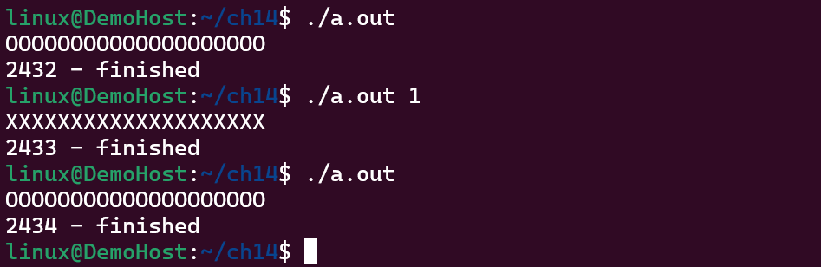
Step 2：Read the code thoroughly, take advantage of the corresponding method of P, V to synchronize process running.
P:

if (!semaphore_p()) exit(EXIT_FAILURE);
printf("%c", op_char);fflush(stdout);
pause_time = rand() % 3;
sleep(pause_time);
printf("%c", op_char);fflush(stdout);
V：

if (!semaphore_v()) exit(EXIT_FAILURE);

pause_time = rand() % 2;
sleep(pause_time);
主函数中的循环体就是一个临界区，每个进程都需要通过P操作来等待信号量，进入临界区后执行任务，然后通过V操作释放信号量，让其他进程可以进入临界区。
Step 3：Input code 6-3 and 6-4, compile, run, and record the result.
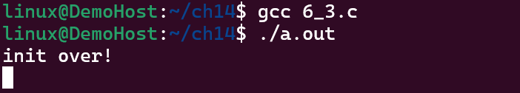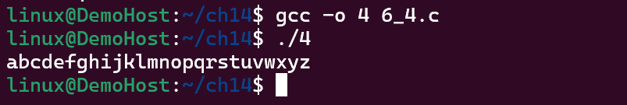
Step 4：Which snippets in codes 6-3 and 6-4 implement sharing, describe the parameter meaning of the corresponding functions that implement memory sharing and how these functions are used.
if((shmid = shmget(key,SHMSZ,IPC_CREAT|0666))<0) {
perror("shmget error");
exit(0);
}
if((shm = shmat(shmid,NULL,0)) == (char *)-1) {
perror("shmat error");
exit(0);
}
shmget（key，size，shmflg）：创建或访问由密钥标识的共享内存段。 size参数以字节为单位指定段的大小，shmflg指定段的权限。 在这种情况下，IPC_CREAT标志用于创建不存在的段，0666权限位允许所有用户对该段进行读写访问。
shmat（shmid，shmaddr，shmflg）：将shmid标识的共享内存段附加到调用进程的地址空间。 shmaddr参数是连接数据段的首选地址（或NULL，用于系统选择地址），shmflg指定连接数据段时的行为。 在这种情况下，值0用于shmflg，这意味着系统选择合适的地址，并且将段附加为读写。
Step 5：Learn and use Semaphore and Shared memory in IPC, rewrite the code in step 6 of project 3. Require multiple processes whose manipulation on the file stu.info are synchronized by semaphores, and these manipulation are mapped to the Shared memory.

3 Summary
shmget和shmat函数在两个代码段中都用于创建共享内存段并将其附加到调用进程，而putchar函数用于将共享内存的内容输出到代码6-4中的标准输出。 最后，shmdt函数用于从调用进程分离共享内存段。

4 Codes List
// 6-1
#if defined(__GNU_LIBRARY__) && !defined(_SEM_SEMUN_UNDEFINED)
/* union semun is defined by including <sys/sem.h> */
#else
/* according to X/OPEN we have to define it ourselves */
union semun {
int val; /* value for SETVAL */
struct semid_ds *buf; /* buffer for IPC_STAT, IPC_SET */
unsigned short int *array; /* array for GETALL, SETALL */
struct seminfo *__buf; /* buffer for IPC_INFO */
};
#endif

// 6-2
#include <unistd.h>
#include <stdlib.h>
#include <stdio.h>

#include <sys/types.h>
#include <sys/ipc.h>
#include <sys/sem.h>

#include "semun.h"

static int set_semvalue(void);
static void del_semvalue(void);
static int semaphore_p(void);
static int semaphore_v(void);

static int sem_id;

int main(int argc, char *argv[])
{
int i;
int pause_time;
char op_char = 'O';

srand((unsigned int)getpid());

sem_id = semget((key_t)1234, 1, 0666 | IPC_CREAT);
printf("semid = %d\n",sem_id);

if (argc > 1) {
if (!set_semvalue()) {
fprintf(stderr, "Failed to initialize semaphore\n");
exit(EXIT_FAILURE);
}
op_char = 'X';
sleep(5);
}

/* Then we have a loop which enters and leaves the critical section ten times. There, we first make a call to semaphore_p which sets the semaphore to wait, as this program is about to enter the critical section. */

for(i = 0; i < 10; i++) {

if (!semaphore_p()) exit(EXIT_FAILURE);
printf("%c", op_char);fflush(stdout);
pause_time = rand() % 3;
sleep(pause_time);
printf("%c", op_char);fflush(stdout);

/* After the critical section, we call semaphore_v, setting the semaphore available, before going through the for loop again after a random wait. After the loop, the call to del_semvalue is made to clean up the code. */

if (!semaphore_v()) exit(EXIT_FAILURE);

pause_time = rand() % 2;
sleep(pause_time);
}

printf("\n%d - finished\n", getpid());

if (argc > 1) {
sleep(10);
del_semvalue();
}

exit(EXIT_SUCCESS);
}

/* The function set_semvalue initializes the semaphore using the SETVAL command in a semctl call. We need to do this before we can use the semaphore. */

static int set_semvalue(void)
{
union semun sem_union;

sem_union.val = 1;
if (semctl(sem_id, 0, SETVAL, sem_union) == -1) return(0);
return(1);
}

/* The del_semvalue function has almost the same form, except the call to semctl uses the command IPC_RMID to remove the semaphore's ID. */

static void del_semvalue(void)
{
union semun sem_union;

if (semctl(sem_id, 0, IPC_RMID, sem_union) == -1)
fprintf(stderr, "Failed to delete semaphore\n");
}

/* semaphore_p changes the semaphore by -1 (waiting). */

static int semaphore_p(void)
{
struct sembuf sem_b;

sem_b.sem_num = 0;
sem_b.sem_op = -1; /* P() */
sem_b.sem_flg = SEM_UNDO;
if (semop(sem_id, &sem_b, 1) == -1) {
fprintf(stderr, "semaphore_p failed\n");
return(0);
}
return(1);
}

/* semaphore_v is similar except for setting the sem_op part of the sembuf structure to 1, so that the semaphore becomes available. */

static int semaphore_v(void)
{
struct sembuf sem_b;

sem_b.sem_num = 0;
sem_b.sem_op = 1; /* V() */
sem_b.sem_flg = SEM_UNDO;
if (semop(sem_id, &sem_b, 1) == -1) {
fprintf(stderr, "semaphore_v failed\n");
return(0);
}
return(1);
}

// 6-3
#include <sys/types.h>
#include <sys/ipc.h>
#include <sys/shm.h>
#include <stdio.h>
#include <stdlib.h>
#include <sys/types.h>
#define SHMSZ 27
int main(void)
{
char c;
int shmid;
key_t key;
char *shm,*s;

key = 1234;
if((shmid = shmget(key,SHMSZ,IPC_CREAT|0666))<0) {
perror("shmget error");
exit(0);
}

if((shm = shmat(shmid,NULL,0)) == (char *)-1) {
perror("shmat error");
exit(0);
}
s = shm;
for(c = 'a'; c <= 'z'; c++)
*s++ = c;
*s = NULL;
printf("init over!\n");
while(*shm != '*')
sleep(1);
exit(0);
}

// 6-4
#include <sys/types.h>
#include <sys/ipc.h>
#include <sys/shm.h>
#include <stdlib.h>
#include <string.h>
#include <stdio.h>
#define SHMSZ 27
int main(void)
{
int shmid;
key_t key;
char *shm,*s;

key = 1234;
if((shmid = shmget(key,SHMSZ,0666)) < 0){
perror("shmget error!");
exit(0);
}
if((shm = shmat(shmid,NULL,0)) == (char *)-1){
perror("shmat error!");
exit(0);
}
for(s = shm; *s != NULL; s++)
putchar(*s);
putchar('\n');
*shm = '*';
exit(0);
}

Project 7 Socket

1 Goal
Learn how to use socket to do remote process communication.

2 Steps
Step 1：Input, compile and run code 8-1and 8-2, record the result.
____________________________________________________________________________________________________________________________________________________________________________________________________________________________________________________________________________________________________________________________
Step 2：Learn and use the basic socket function, rewrite the codes of the previous projects. Require the client inputs the data manipulation command, and then send it to the server to do the actual manipulation. Please try to use the results of the previous projects that should include multi-thread or multi-process, etc.

3 Summary
_________________________________________________________________________________________________________________________________________________________________________________________________________________________________________________________________________________________________________________________________________________________________________________________________________________________________________________________________________________________________________________________________________________________________________

4 Codes List
// 8-1
#include <sys/types.h>
#include <sys/socket.h>
#include <stdio.h>
#include <netinet/in.h>
#include <arpa/inet.h>
#include <unistd.h>

int main()
{
int sockfd;
int len;
struct sockaddr_in address;
int result;
char string[256];
char rcv[256];

/* Create a socket for the client. */

sockfd = socket(AF_INET, SOCK_STREAM, 0);

/* Name the socket, as agreed with the server. */

address.sin_family = AF_INET;
address.sin_addr.s_addr = inet_addr("127.0.0.1");
address.sin_port = htons(9734);
len = sizeof(address);

/* Now connect our socket to the server's socket. */

result = connect(sockfd, (struct sockaddr *)&address, len);

if(result == -1) {
perror("oops: client");
exit(1);
}

/* We can now read/write via sockfd. */
printf("enter some message: ");fflush(stdout);
fgets(string,sizeof(string),stdin);

write(sockfd, string, sizeof(string));
read(sockfd, rcv, sizeof(rcv));
printf("from server = %s\n", rcv);
close(sockfd);
exit(0);
}

// 8-2
#include <sys/types.h>
#include <sys/socket.h>
#include <stdio.h>
#include <netinet/in.h>
#include <arpa/inet.h>
#include <unistd.h>

int main()
{
int server_sockfd, client_sockfd;
int server_len, client_len;
struct sockaddr_in server_address;
struct sockaddr_in client_address;
char string[256];
char *ans = "yes!";

/* Create an unnamed socket for the server. */

server_sockfd = socket(AF_INET, SOCK_STREAM, 0);

/* Name the socket. */

server_address.sin_family = AF_INET;
server_address.sin_addr.s_addr = inet_addr("127.0.0.1");
server_address.sin_port = htons(9734);
server_len = sizeof(server_address);
bind(server_sockfd, (struct sockaddr *)&server_address, server_len);

/* Create a connection queue and wait for clients. */

listen(server_sockfd, 5);
while(1) {
char ch;

printf("server waiting\n");

/* Accept a connection. */

client_len = sizeof(client_address);
client_sockfd = accept(server_sockfd,
(struct sockaddr *)&client_address, &client_len);

printf("Now,client request come in.\n");
printf("client_address = %s\tclient_port = %u\n",inet_ntoa(client_address.sin_addr),htons(client_address.sin_port));

/* We can now read/write to client on client_sockfd. */

read(client_sockfd, string, sizeof(string));
printf("client send: %s\n",string);
write(client_sockfd, ans, sizeof(ans));
close(client_sockfd);
}
close(server_sockfd);
}

